Creating Useful Guides & Infographics for a Remote Setting
Writing Internship Program
Mariah Lanzer
Senior Honors English Major

Prepared for

Dr. Uma Krishnan
Director of Writing Internship Program

Ms. Maegan Richards
Columbiana County Academic Learning Commons Coordinator

December 3, 2020
Table of Contents
ABSTRACT………………………………………………………………………………………ii
INTRODUCTION………………………………………………………………………………...1
DISCUSSION……………………………………………………………...................................2-5
LibGuides……………………………………………………………………………….2-3
Canva Infographics for Social Media Pages………………………………………….…3-5
Scripts for Tutorial Videos………………………………………………………………...5
WIP MEETINGS………………………………………………………….....................................6
CONCLUSION……………………………………………………………………………………7
RECOMMENDATIONS………………………………………………………………………….8
APPENDIX……………………………………………………………………………………9-26
“Writing Across the Curriculum: Discipline-Specific Resources” LibGuide…………9-12
“2020 Presidential and Local Elections” LibGuide………………………………….13-16
“We are still here to help!” Infographic………………………………………………….17
“Writer’s Hotline” Infographic…………………………………………………………..18
“The Writing Process: Always Messy, Never Easy” Infographic……………………….19
“Power Hour Nursing and Radiology Sessions” Infographic……………………………20
“Power Hour Sciences Sessions” Infographic…………………………………………...21
“Thanksgiving Break” Infographics…………………………………………………22-23
“Finals Week” Infographic……………………………………………………………...24
“Scheduling a Tutoring Session” Script for Video Tutorial………………………….25-26

Abstract
Information that is easily accessible in a remote setting is essential for students’ success. Keeping students well-informed of the services that are still available to them was the purpose of my writing internship, and I did this by creating various online resources, such as infographics and LibGuides. The infographics were posted on the Columbiana County Writing Center social media pages, which have been mentioned by instructors in order to gain views from students. The LibGuides are published online and easily accessible.
As a writing tutor and SURE researcher, I have experience with writing resources and Writing Across the Curriculum (WAC) programs. Therefore, a large part of my internship was spent creating a WAC LibGuide that offers discipline-specific writing resources for majors other than English, such as nursing, psychology, and business. Providing these resources to students that may not know how to write within their discipline is essential to their success.
Visiting the writing center and gaining an outside perspective to a paper is also something I find to be beneficial to students. The purpose of the infographics that I created was to make students aware of the writing center and its resources. Letting students know that the writing center is still there during this remote time, and that remote tutoring is available, is a step towards keeping them interested in and aware of the writing center and all that it has to offer.
This writing internship experience was very rewarding. Knowing that I was able to offer these resources to students made this internship valuable, both to myself and to others. Everything that I learned about workplace writing will help me succeed in my future writing career.

Introduction
The Kent State-Salem Writing Center has been making progress in what it has to offer. During the summer of 2020 I participated in the Summer Undergraduate Research Experience (SURE) program with writing center coordinator Dr. Barbara George. During these three months of research I engaged in texts about Writing Across the Curriculum (WAC) and how different universities run this program in their writing centers. I also conducted research on the social media pages of these writing centers and took note of ideas that I felt our own writing center could use, such as: a writing center hotline for quick questions and a web page full of online writing resources for all disciplines. This research prepared me for this writing internship.
I decided to conduct my writing internship with Ms. Richards in the Academic Learning Commons because I had prior experience in this setting. As both a writing tutor and a library clerk, I am familiar with tasks that Ms. Richards needs assistance with. The research I conducted over the summer also helped prepare me for the projects that I created throughout this internship. I continued this work with Ms. Richards by creating a LibGuide full of writing resources for all popular disciplines on the Columbiana County campuses. I continued to engage with the LibGuides application by making a 2020 Presidential Election LibGuide. These guides are now published and able to be viewed by the public.
Besides creating LibGuides, I also designed infographics for the writing center’s new social media pages. These infographics are targeted towards letting students know that we now have a writer’s hotline, what our Power Hour schedules look like, and more. Creating resources and infographics that are helpful for students has been rewarding, especially during remote learning: everyone needs a little extra help or reminders during this difficult time.

Discussion
LibGuides
A week prior to the start of the internship Ms. Richards and I spoke over the phone about the projects I would begin. In order to continue with the SURE research and findings, Ms. Richards and I felt that it would be useful to begin with creating a LibGuide that offers writing resources for disciplines outside of English. In order to do this, I first had to gain access to the LibGuides application, and then learn how to utilize it. Once I was able to log into LibGuides, I was given access to all the training videos. After watching two one-hour videos, I felt confident enough to begin my first LibGuide.
My first LibGuide, titled “Writing Across the Curriculum: Discipline-Specific Resources,” is a guide that offers writing resources for popular disciplines on the Columbiana County Kent campuses. These disciplines include business, nursing, psychology, horticulture, early childhood education, and life sciences. For each discipline’s individual page there are writing resources, citation guides, and research databases. However, finding writing resources for some of these disciplines was difficult. For example, there are not many writing resources and guides available for horticulture. Therefore, I had to reach out to one of Kent State-Salem’s horticulture instructors, Dr. Sarah Eichler. Dr. Eichler provided me with Extension resources to explore, which are full of writing guides, reports, and other useful horticulture resources. I was able to fill the horticulture page with these resources.
As I continued searching for writing resources, I also began working on another LibGuide that Ms. Richards suggested. This LibGuide is titled, “2020 Presidential and Local Elections,” and I created it so that students in the Columbiana County region would have information about the upcoming election. This LibGuide not only offers nonpartisan information about the election and its candidates, but also provides information on local elections. In the tab “Local Elections 2020” there are links to each county’s board of elections that are near the Columbiana campuses, such as Mahoning, Trumbull, and Stark. In the “Registration” tab there is information regarding registering to vote in the state of Ohio. A link to request an absentee ballot can also be found on this page.
I completed the 2020 Election LibGuide first so that students would be able to view it before the election. Before publishing it, Ms. Richards and I looked it over together via a telephone call and made adjustments. I published it afterwards, making it viewable to the public. So far, there have been twelve views. The WAC LibGuide does not currently have any views, but this is because it was published much later than the election LibGuide. The WAC LibGuide took far longer to finish because I not only had to find writing resources, but also had to make sure that they were accurate and acceptable.
Canva Infographics for Social Media Pages
My projects after the LibGuides consisted of designing infographics for the Kent State-Salem Writing Center’s new social media pages. Dr. George created a Facebook page for the writing center, and I created an Instagram page. Once they were created, Ms. Richards and I shared ideas for the first posts. Ms. Richards also shared Kent State’s designs and colorways with me so that each infographic had the Kent State “feel” to it. I then created my first infographic via Canva, called “We are still here to help!” This infographic addresses the different kinds of remote tutoring that we offer and the hours that we are available. There is also a link provided that will lead students to the scheduler. This infographic was posted on both the Facebook and Instagram pages.
I designed my next infographic with the intention of disseminating the creation of Kent State-Salem’s new Writer’s Hotline. This hotline is available through direct messages on our social media pages, and students can utilize this messaging service to ask writing tutors quick questions. This infographic contains all this information, as well as the usernames of each social media page. The infographic also states that the hotline is for quick writing questions and concerns only. Any student with a question that would require a session to be answered will be advised to schedule one with a writing tutor.
The third infographic I created was my own idea: I decided to create an infographic about the writing process. The title of this graphic is called, “The Writing Process: Always Messy, Never Easy.” As a writing tutor, I am aware of the complaints that many students have when they come into the writing center. “I can’t write” is one that I hear often, as well as “My paper is a mess.” I felt that this infographic would be encouraging for students who feel this way about their papers. Knowing that the writing process is messy for everyone and that there is no set, linear writing regime can show new students that they are not alone in the messiness of their papers. After creating this infographic, I shared it with both Dr. George and Ms. Richards. They both approved of it, so I posted it on both social media pages.
The next two infographics that I created were at the request of Ms. Richards. She felt that we should have a couple infographics displaying our Power Hour schedules. Ms. Richards wanted the schedules to be divided by discipline. Therefore, I created an infographic with the nursing and radiology Power Hour information, and another with all the sciences’ Power Hour information. Both list the session names, the instructor for each, and the days and times the sessions are available. Once both infographics were approved by Ms. Richards, I posted them on the social media pages.
The final infographic projects I worked on were for Thanksgiving break and finals week. The Thanksgiving break infographic displays the days that writing tutors would be unavailable and when they would return. I created a similar infographic that also displays this information for the Power Hour sessions. Both were posted to social media accounts when Thanksgiving break began. I also began creating an infographic for finals week, but that one has yet to be posted.
Scripts for Tutorial Videos
The final projects that I began working on for Ms. Richards were scripts for tutorial videos. After being told that several students were having difficulty accessing the scheduler, Ms. Richards decided that a tutorial video should be created. Because I have experience with using the scheduler, I began writing the script for the tutorial. I also began writing a script for a tutorial on how to access Microsoft Word for free as a Kent State student, but I was unable to finish it. However, Ms. Richards and I plan to continue this work during my scheduled library hours.

WIP Meetings
The writing internship progress meetings were beneficial to my success in this internship. Sharing my experiences with my fellow interns provided me with a sense of comfort and community, which is especially beneficial when working in a remote setting. Being aware of my fellow interns’ projects also inspired me to come up with ideas for my own internship. However, what I benefited from the most was the ageless advice and techniques in professional and technical writing that Dr. Krishnan provided.
Although I was prepared for this internship with a professional writing course, Dr. Krishnan prolonged my learning by providing examples and advice in each meeting. For example, one meeting was spent looking at examples of resumes. After this meeting, my fellow interns and I created our own resumes and shared them with each other. In the following meeting Dr. Krishnan looked over the resumes and helped improve them. We eventually did this with cover letters as well, but not until we searched for jobs of interest that we could apply for. Dr. Krishnan taught us how to be specific in our cover letters for each job, which has prepared us all for the job application process.
Towards the end of the internship, Dr. Krishnan advised us to update our LinkedIn profiles. This led to me creating a LinkedIn profile since I did not have one beforehand. Dr. Krishnan’s suggestions helped me greatly, especially since this was my first time using this application. I am now connected with Dr. Krishnan and my fellow interns, and feel confident and ready to connect with employers.

Conclusion
My writing internship has provided me with rewarding experiences. To be able to provide vital information to students in a remote setting is worthwhile and something that I plan to continue in graduate school. Knowing that I was helping others in this internship was valuable to me, and I strive to keep that purpose in my future career. However, this experience would not have been as enjoyable without Ms. Richards and Dr. Krishnan.
As a student worker employed by Ms. Richards, working with her was not a new endeavor. However, this internship made me feel even more connected to her and the Academic Learning Commons. This internship made me realize how much the ALC has to offer students. Most importantly, this internship showed me how much Ms. Richards goes out of her way to help students. She is truly passionate about her job and helping students, and I am forever grateful for this experience with her.
Dr. Krishnan never failed to teach me something new in the bi-weekly internship meetings. She taught and enforced professionalism, technical workplace writing, and constantly demonstrated rapport with her interns. The lessons and examples that Dr. Krishnan provided taught me that workplace writing is clear, coherent, and concise, and I will integrate this in the future as I begin applying for graduate school and assistantships. I will carry this writing internship experience with me and continue to incorporate all that I have learned in my future writing career.

Recommendations
Dr. Krishnan and Ms. Richards had no control over the remote setting that this writing internship was conducted. If I had to make a recommendation, it would be that this internship was in-person. However, I am still grateful for the experience and all the time and effort that both Dr. Krishnan and Ms. Richards put into making this internship the best it could possibly be.
The other recommendation that I have is also out of my supervisors’ control. If I could ask for one more thing, it would be for more time. Ms. Richards and I had other projects in mind, and I would have been delighted to work on them. However, as one of Ms. Richards’s student workers, I am sure that I will be given the opportunity to continue my writing internship work.

Appendix
“Writing Across the Curriculum: Discipline-Specific Resources” LibGuide
Homepage
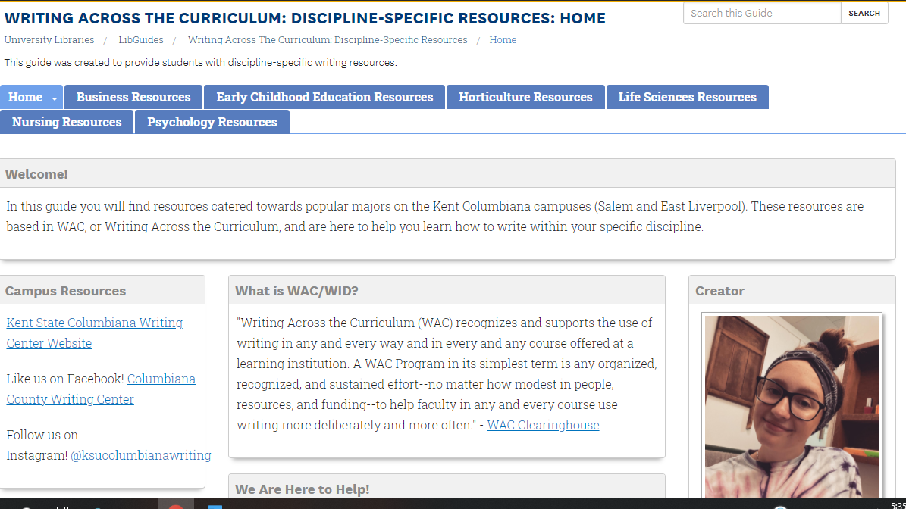

Horticulture page
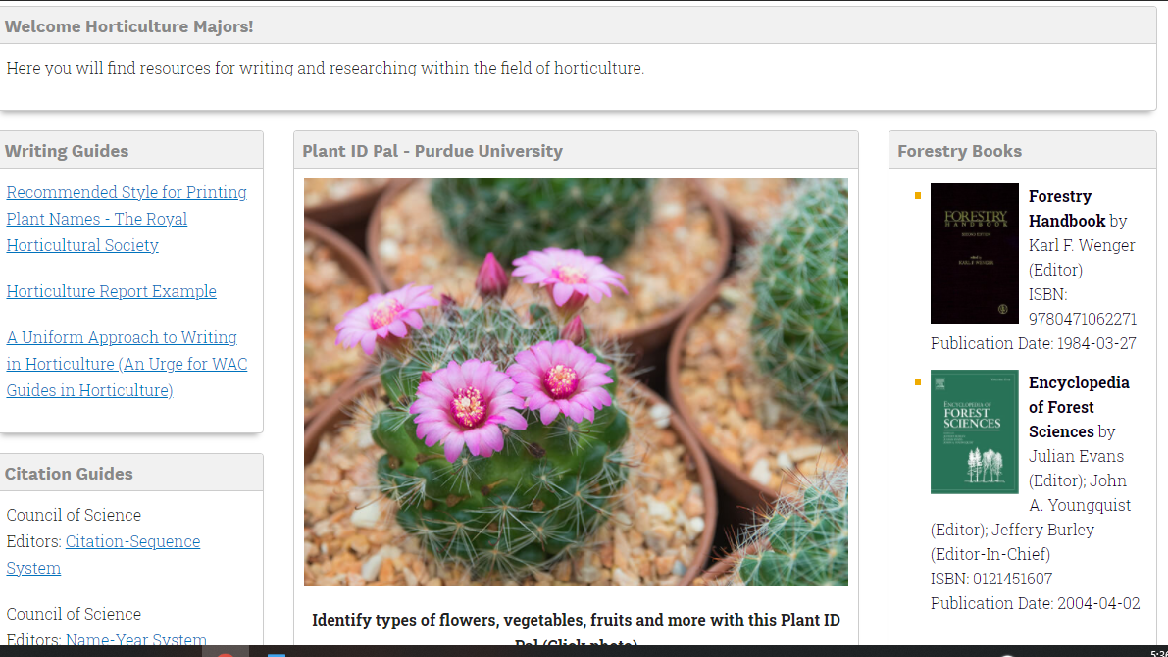

Life Sciences page
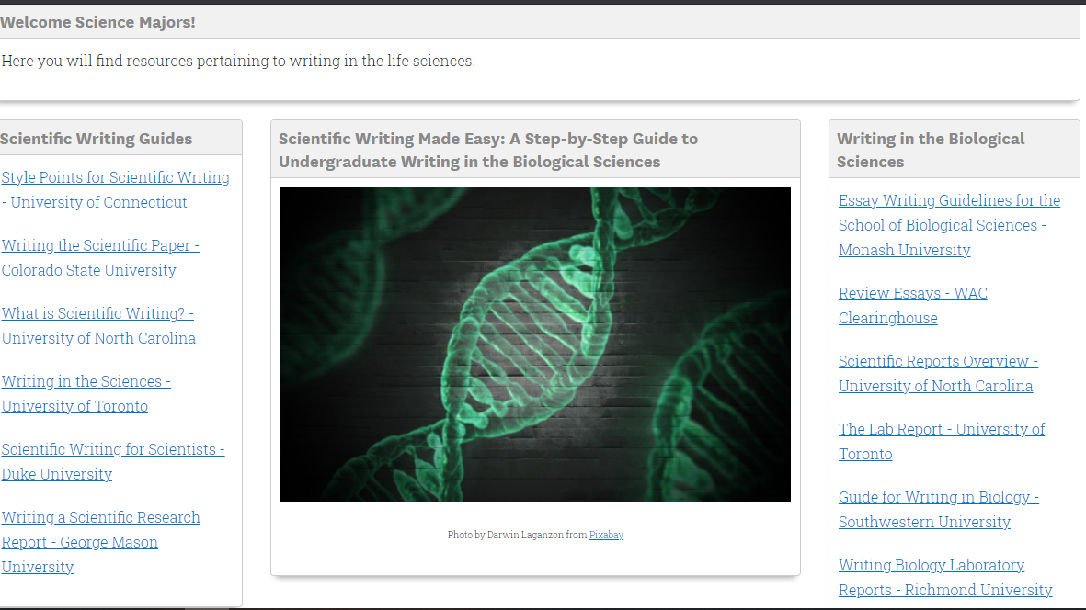
Nursing page
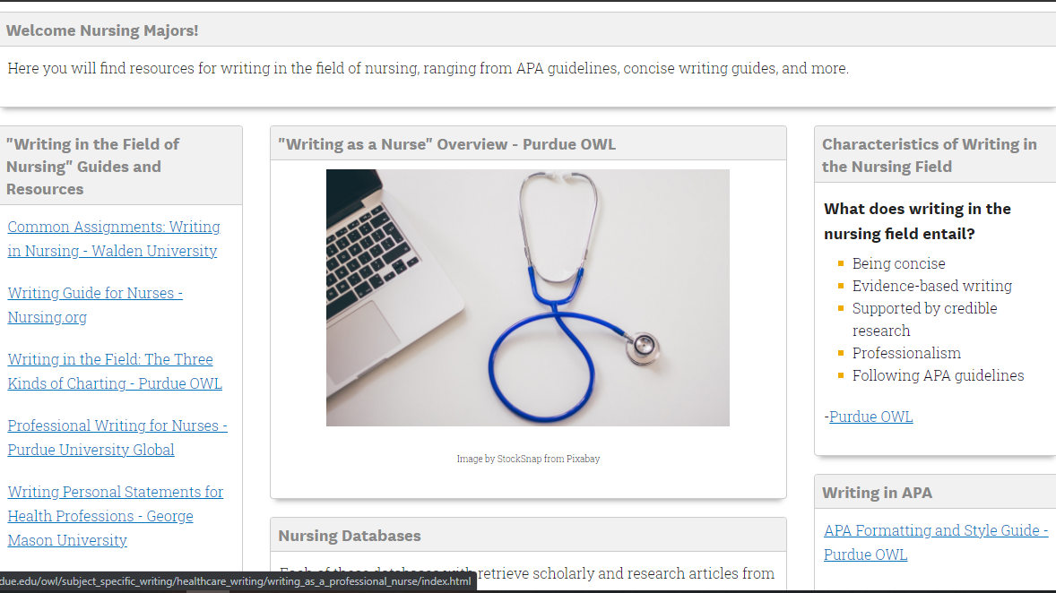

Psychology page 1 of 2
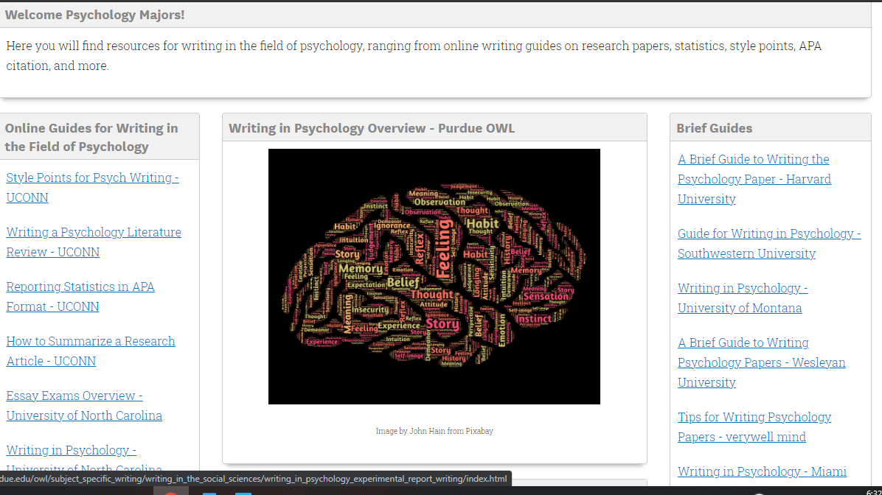
Psychology page 2 of 2
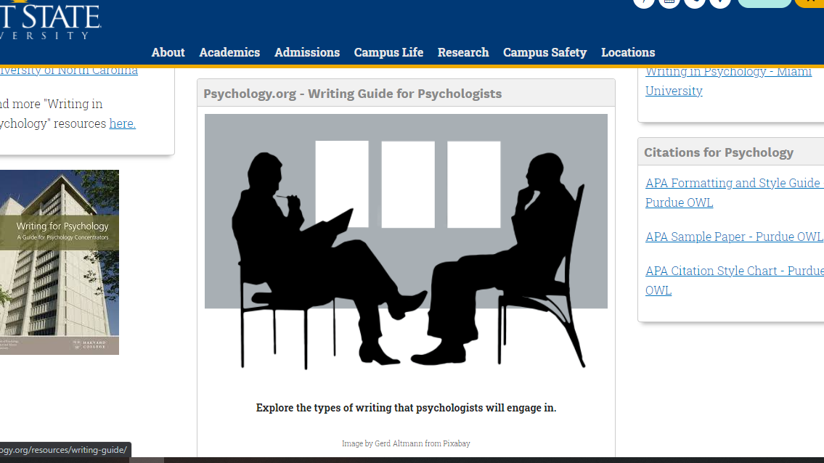
To view entire LibGuide, visit https://libguides.col.kent.edu/writing-across-the-curriculum-resources

“2020 Presidential and Local Elections” LibGuide
Home page
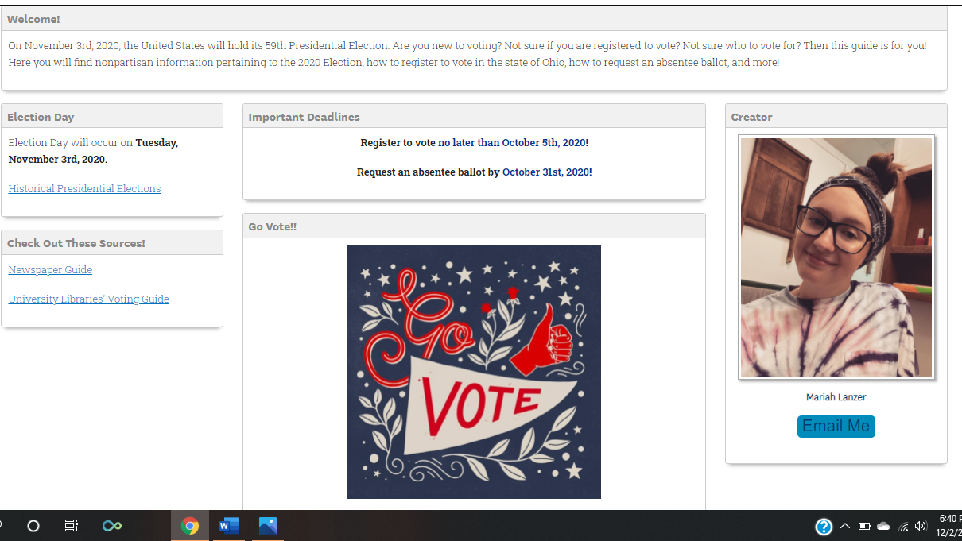

Additional Resources page
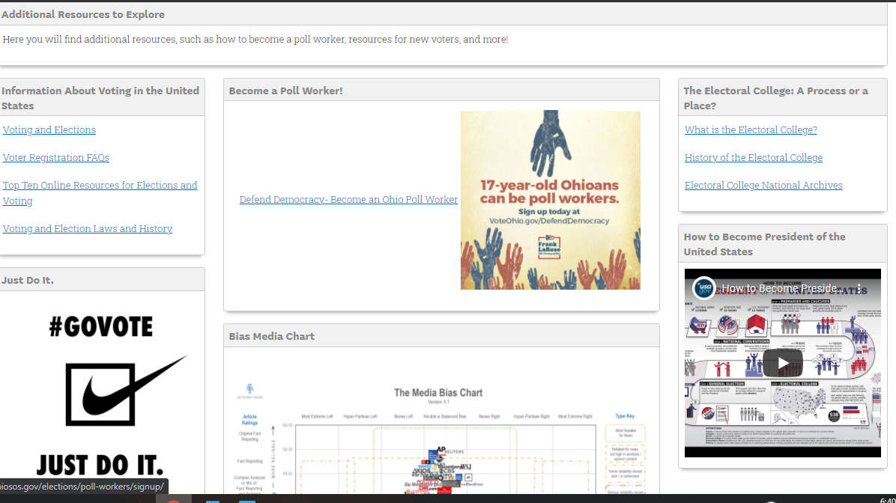

Registration page
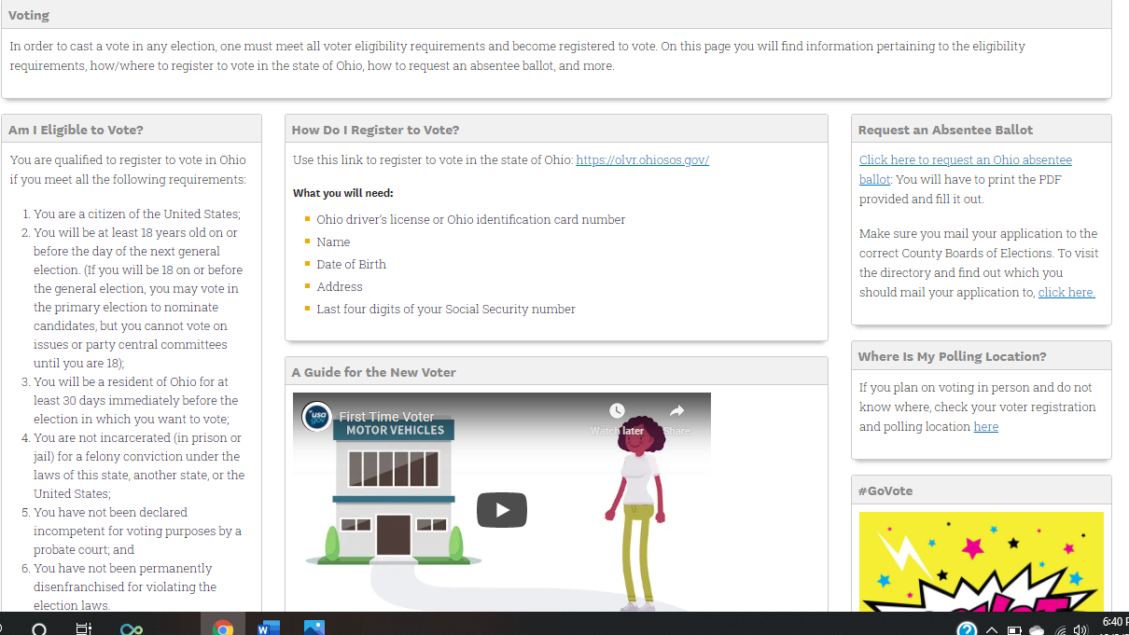
General Election 2020 page
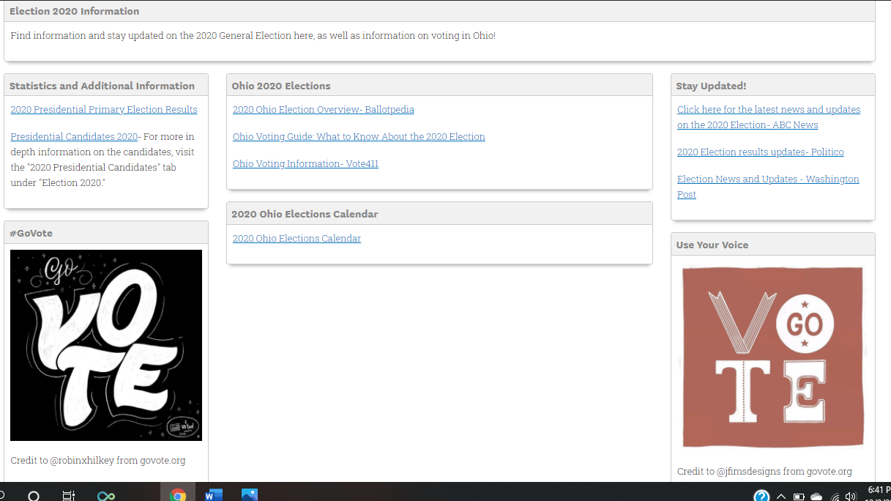

2020 Presidential Candidates page
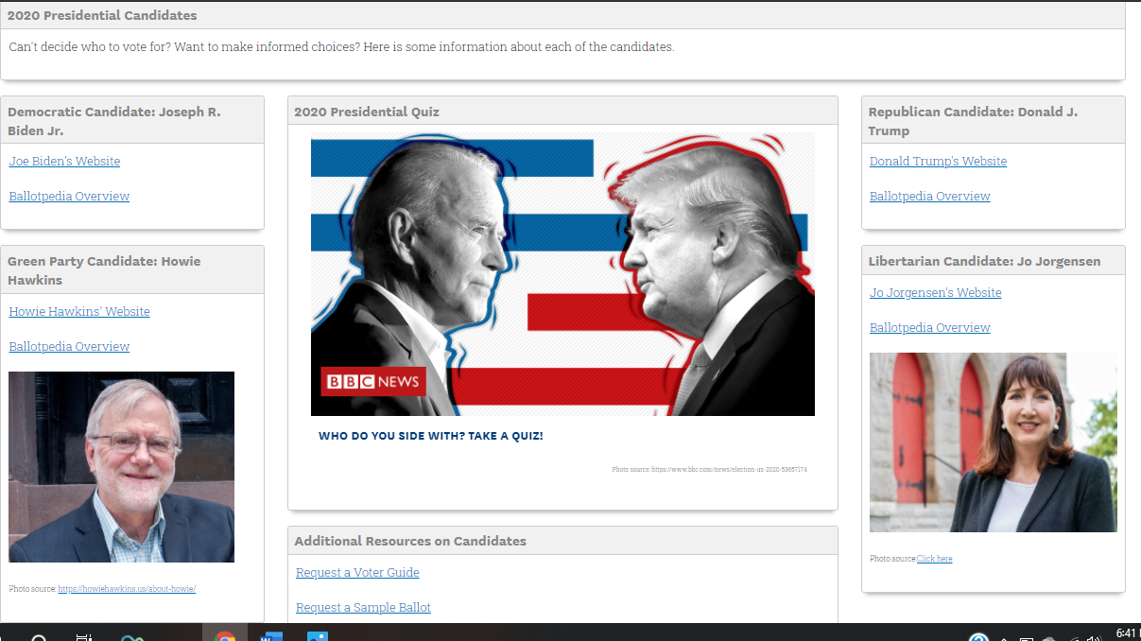
Local Elections 2020 page
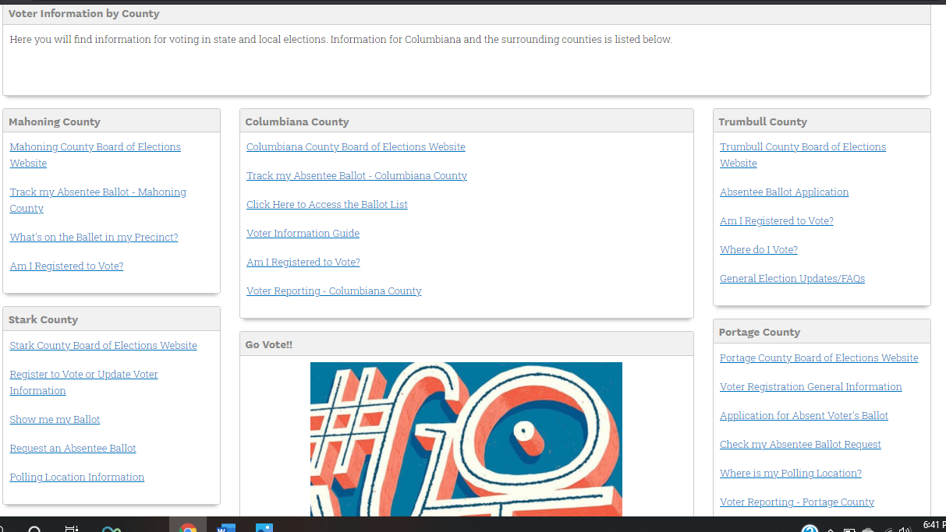
To view entire LibGuide, visit https://libguides.col.kent.edu/2020elections

“We are still here to help!” infographic
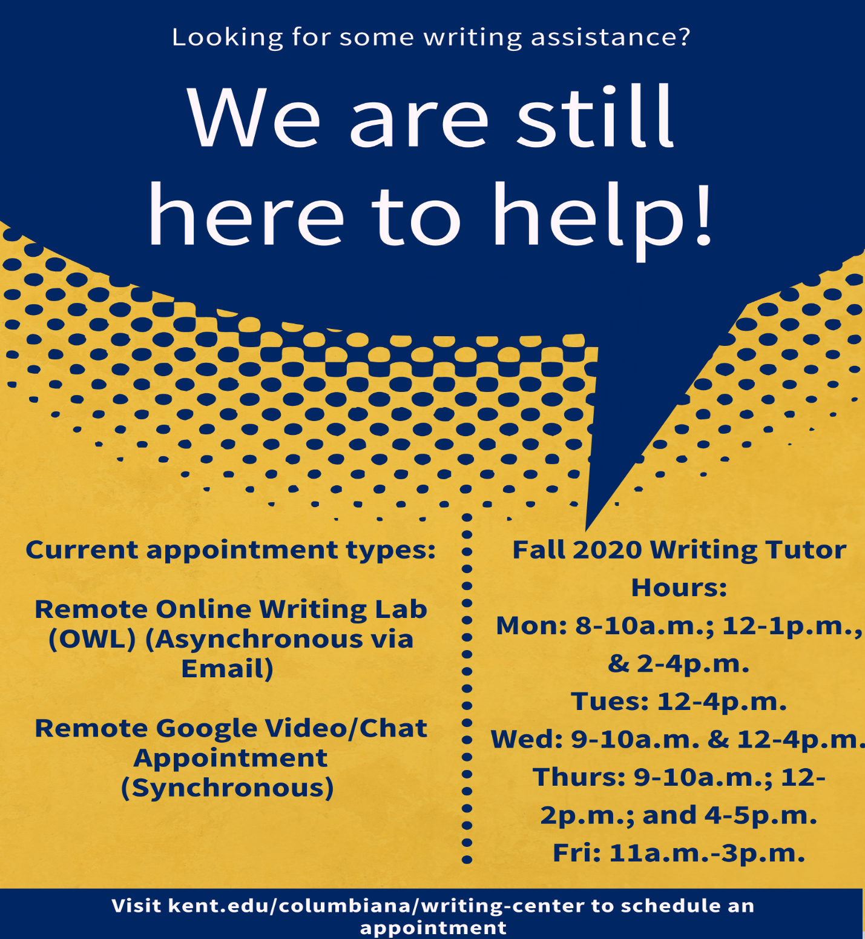

“Writer’s Hotline” infographic
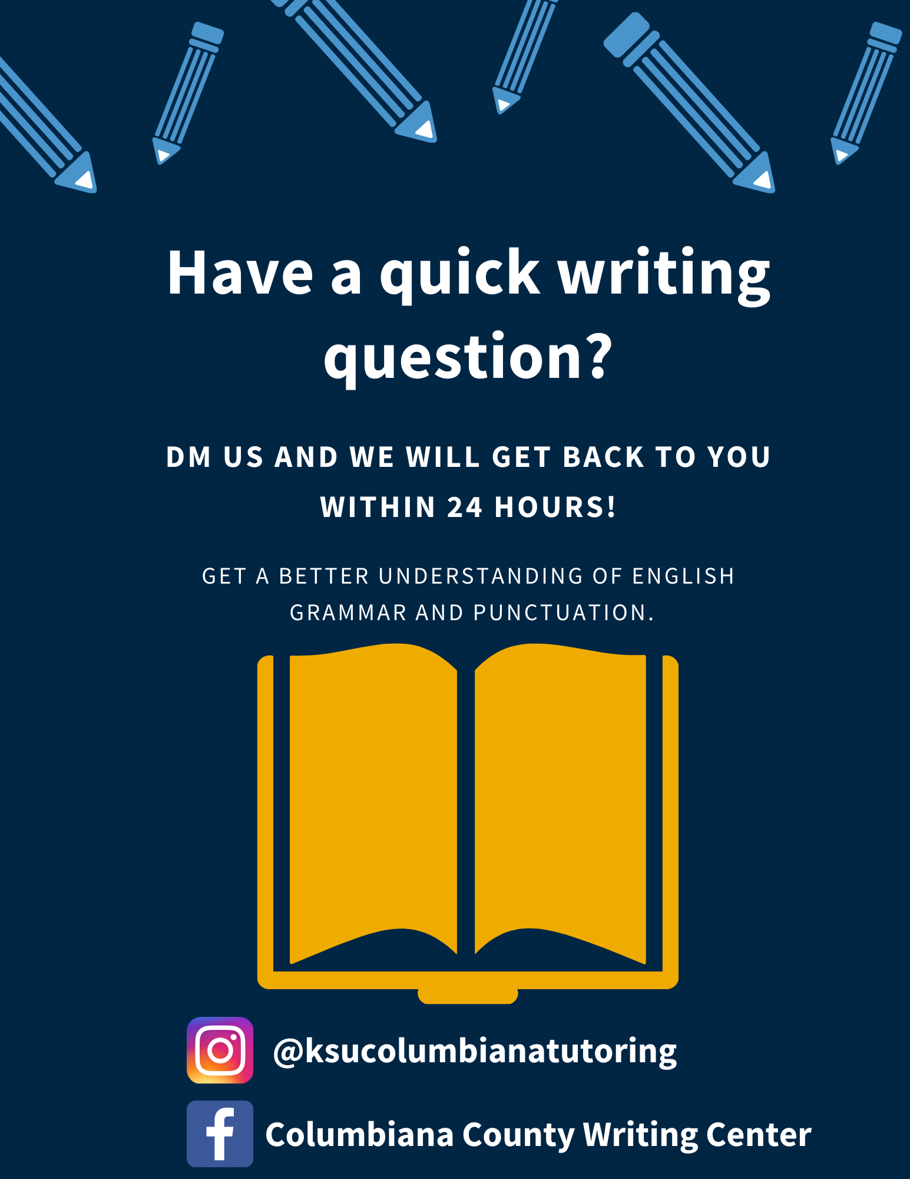
“The Writing Process: Always Messy, Never Easy” infographic
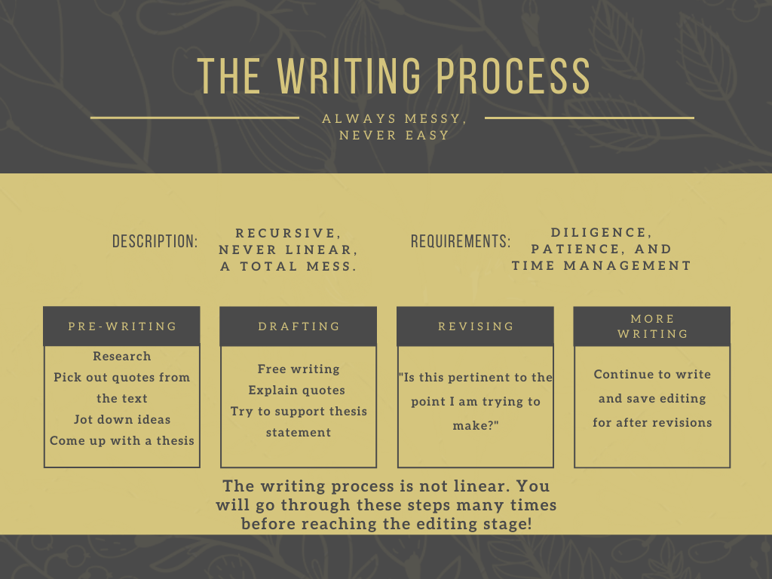

“Power Hour Nursing and Radiology Sessions” infographic
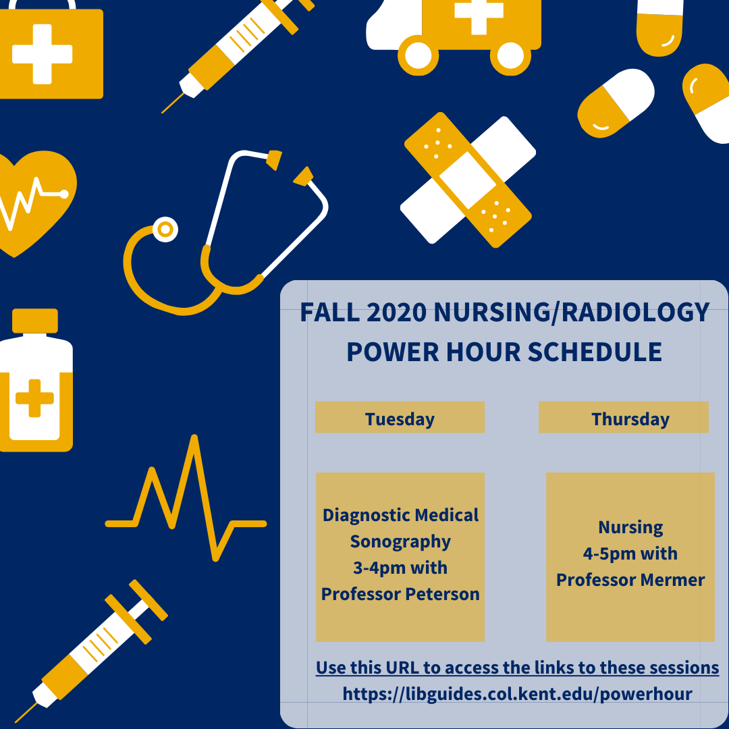

“Power Hour Sciences Sessions” infographic
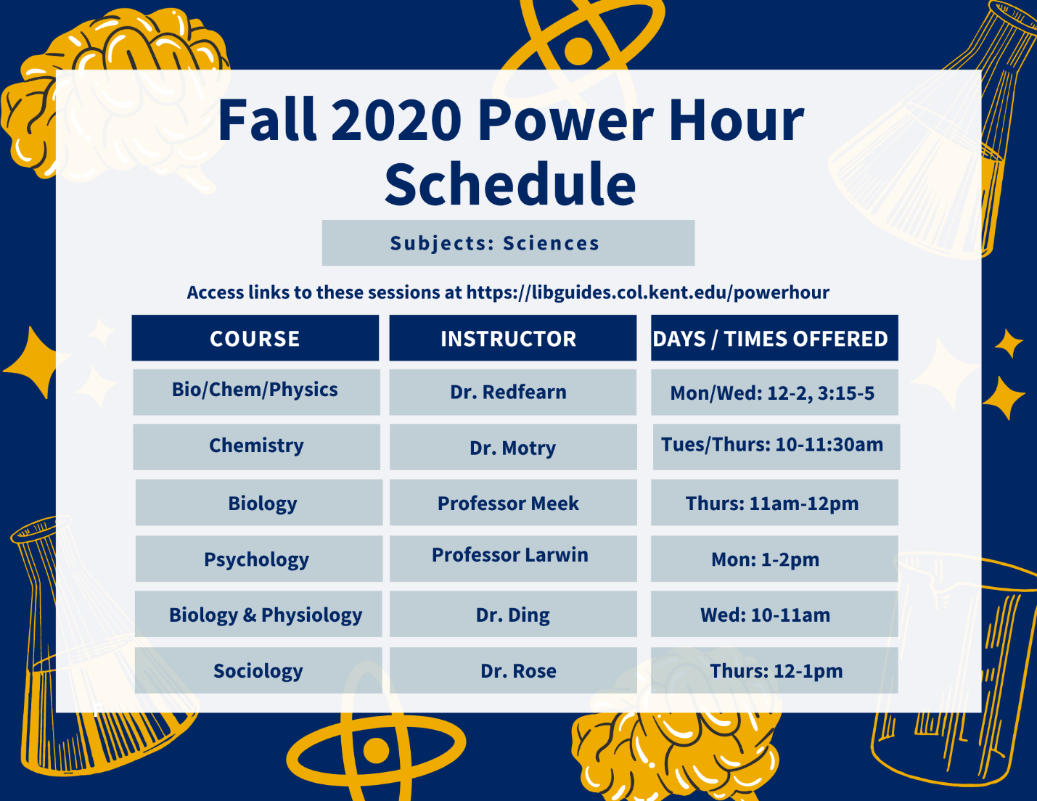

“Thanksgiving Break” infographic 1 of 2
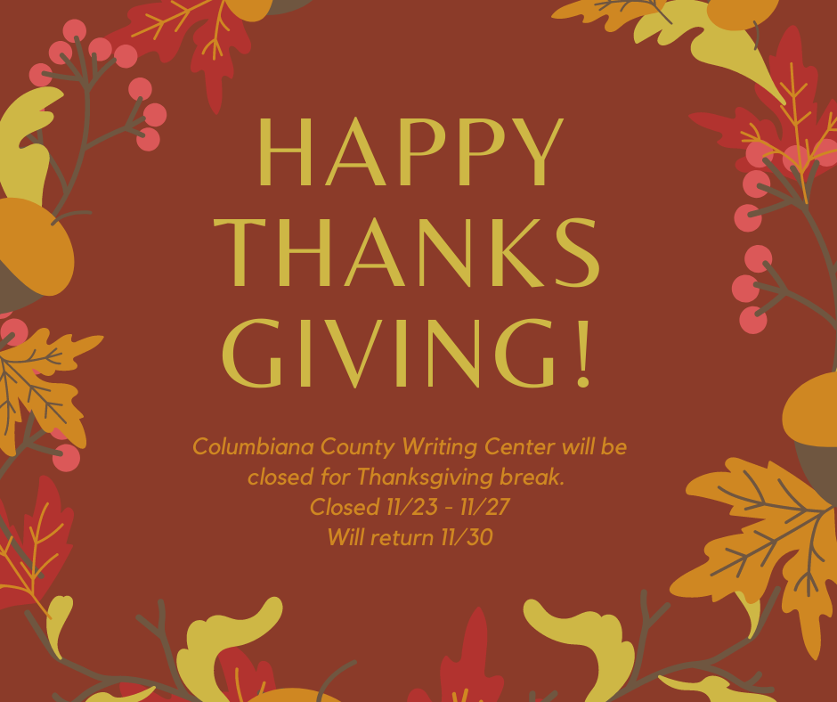

“Thanksgiving Break” infographic 2 of 2
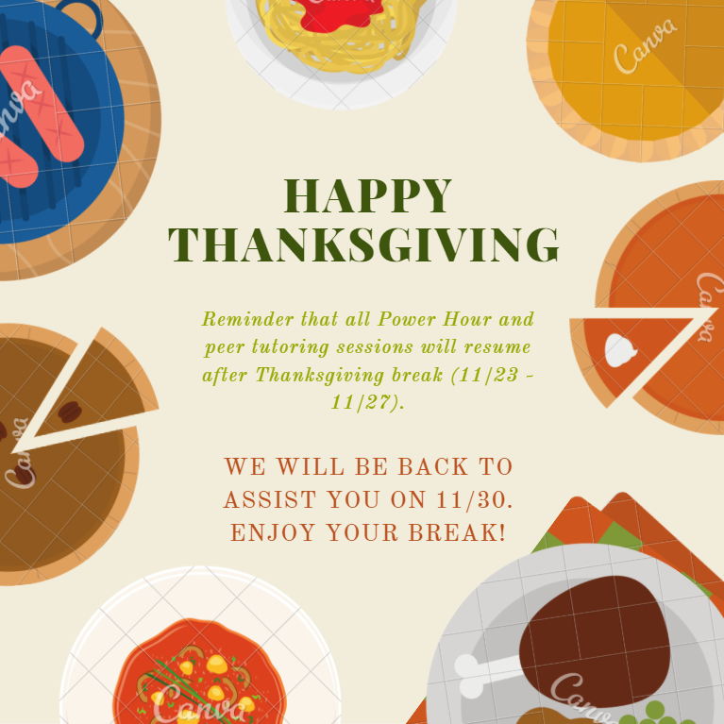

“Finals Week” infographic
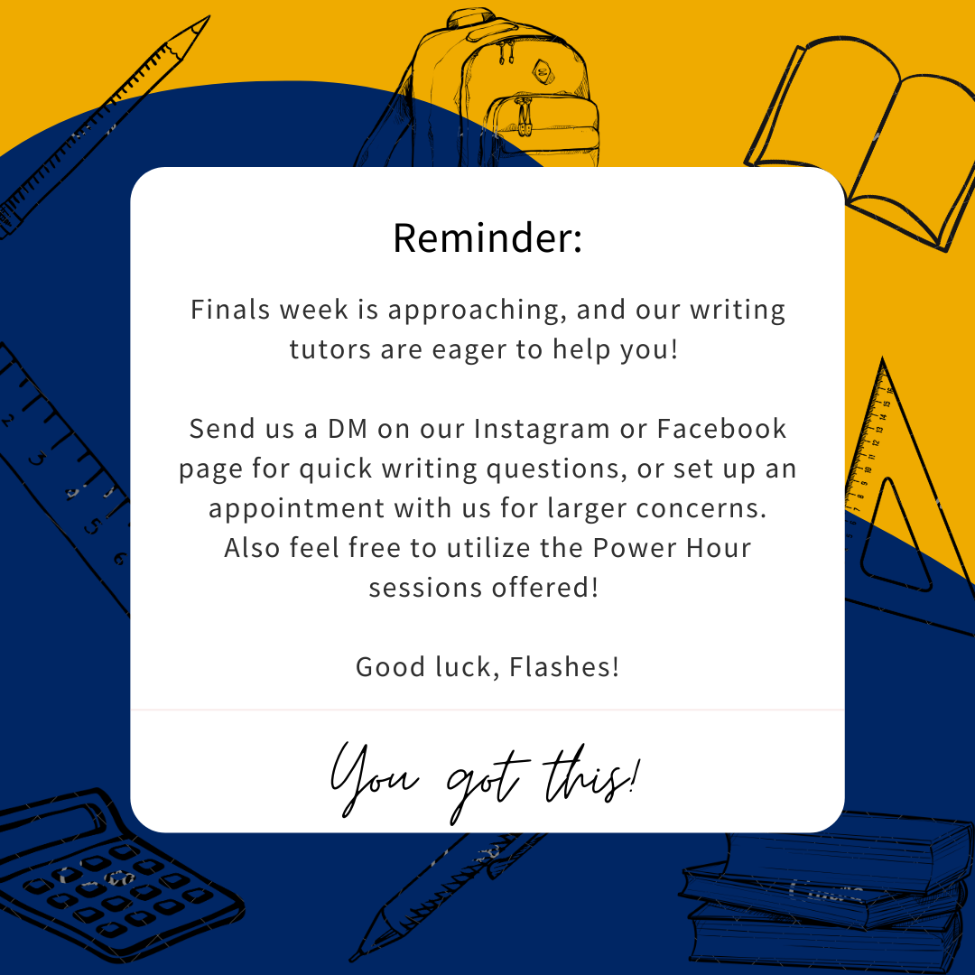

“Scheduling a Tutoring Session” script for video tutorial
Hello, today I am going to show you how you can access the scheduler to sign up for a Google Meet/Chat synchronous writing tutoring session with the Columbiana County Writing Center. The easiest way to access the scheduler is to start on the Kent State Columbiana County Writing Center webpage. You can google “Kent State Columbiana Writing Center” and click on the first link at the top of the results page.
Once you arrive at the writing center webpage, you will scroll down just a little until you see where it says “Scheduler” under “Remote Google Video/Chat Appointment.” You will click on this hyperlink, which will take you to the actual scheduler.
You will see a calendar with many appointments for different disciplines, and through different campuses. What you want to do now is narrow your search to the Columbiana campuses. If this menu hasn’t already dropped down for you, what you will want to do is click this little arrow that is pointing down. It is right above where it says, “All Session Types,” which also lets you know that you are viewing sessions from all the campuses.
Once you click on this drop-down menu, there will be some limits or options for you on the upper left-hand side of the page. The easiest way to limit the search to the Columbiana County campus tutoring sessions is by clicking where it says “All,” and scrolling down to the very bottom of the list where it says, “Salem writing appointment.” Once you click this, it will only display writing sessions that are through the Salem campus, which is also for East Liverpool students. You are now able to see what sessions are still available for you to register, and if you are looking ahead and want a session in a week or maybe more, you can click the arrow on the left hand side above the calendar. This will take you to the next week of sessions.
Once you find an available session that you would like to register for, you will simply click on it. You will be taken to a page where you will login with your Flashline username and password. Once you have logged in, you will be able to register for the session. You will be asked a few questions about yourself, such as your major, class standing, what course this paper is for, what stage of the writing process you are in, and what your concerns are that you would like to address in the session. Any stage of the writing process is welcome in the writing center, as well as any discipline and type of paper.
Once you register for the session, you will receive an email confirmation from the scheduler. You will also receive an email from the tutor that you will be meeting with. That’s it! You have now registered for a tutoring session. If you have any questions or concerns, please use the contact information provided on the KSU Columbiana Writing Center webpage to reach out to a tutoring coordinator.

